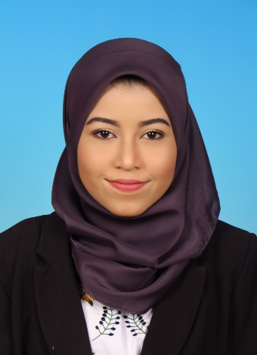
NURUL NADIA BINTI ZAMRI

OBJECTIVE
To obtain a challenging and responsible where I can contribute the best of my skill and effort for growth of the company.

CONTACT INFORMATION
Address : NO 26 JALAN SS 5/10,Taman Seri Saujana, 81900 Kota Tinggi, Johor
Mobile No : 019-7859507
Email :natyazamry @gmail.com

PERSONAL PARTICULARS
Marital Status : Single
Gender : Female
Date of Birth : 29th July 1996
NRIC : 960729-02-5084
Religion : Islam
Nationality : Malaysian
Licence : Driving licence Class D

EDUCATIONAL BACKGROUND
2014-2017
- Diploma In Computer Graphic Design
KOLEJ POLY TECH-MARA BatuPahat, Johor
CGPA : 3.67 (Graduated with Dean’s List)

Semester 1 : GPA 3.00
Semester 2 : GPA 3.56 (Dean’s list)
Semester 3 : GPA 3.90 (Dean’s list)
Semester 4 : GPA 3.82 (Dean’s list)
Semester 5 : GPA 4.00 (Internship)
Semester 6 : GPA 3.88 (Dean’s list)

- Malaysian University English Test
November 2017 : Band 4

2009-2013
- Sijil Pelajaran Malaysia (SPM)
- PenilaianMenengahRendah (PMR)
SekolahMenengahKebangsaan Taman Seri Saujana / SekolahMenengahKebangsaanLaksamana
SPM Achieved : 1A- 2B+ 1B 1C+ 1D 2E
PMR Achieved : 3A 4B 1C

2003-2008
- SekolahKebangsaan Seri Saujana / SekolahKebangsaan Bandar Kota Tinggi
UPSR Achieved : 4A 1B

AWARDS AND ACHIVEMENTS
2017
- Graduate in Diploma Computer Graphic Design with CGPA 3.67
- Received Dean’s List award for semester 6 and 5 at Majlis AnugerahKecemerlanganAkedemik KPTM BatuPahat
2016
- 2_{ND} place in PertandinganFilemPendekKarnivalKebudayaan Dan Kesenian Islam (KALAM) KPTM Semalaysia
- Received Dean’s List award for semester 3 at Majlis AnugerahKecemerlanganAkedemik KPTM BatuPahat
2015
- Received Dean’s List award for semester 2 at Majlis AnugerahKecemerlanganAkedemik KPTM BatuPahat
2013
- 2_{ND} place for the best group on PerkhemahanKecemerlangan Murid SekolahMenengah 1Malaysia PeringkatNegeri Johor
- 2_{ND} place in KejohananHokiBawah 18 Majlis SukanSekolah Daerah Kota Tinggi
2012
- 1_{ST} place in KejohananHokiBawah 18 Majlis SukanSekolah Daerah Kota Tinggi

EXTRA-CURRICULAR ACTIVITIES
2016
- Vice president of Kelab KeseniandanKebudayaanKolej Poly-Tech Mara BatuPahat
2013
- President of Unit MedaSekolahMenengahKebangsaan Taman Seri Saujana
2012
- Crew at Karnival Pendidikan Sivik&KewarganegaraanSekolah-sekolahMenengah Daerah Kota Tinggi
- Attended Program SenamrobikSerentak 1 Murid 1 Sukan 1 Malaysia
SKILLS AND ABILIITIES
LANGUAGE
- Fluent in written and spoken ENGLISH and MALAY
COMPUTER SKILL
- Adobe Photoshop, Adobe Illustration, Adobe InDesign, Adobe Flash, Sound Forge,LightWave, 3D Maya, Microsoft Words, Power Point, Excel, Window Movie Maker, NX7.5, AutoCad
SOCIAL SKILL
- Good Communication
- Leadership and teamwork skill have been archived through involvement with many technical presentation, assignment and internship

PERSONAL STRENGHT
- Have a quality on leadership and management
- Self-motivated and never give up.
- Brave and outstanding person.
- Good listener and advisor
- Creative and can handle critical thinking
- Like to explore on new things
- Dedicated and well-disciplined,
- Extrovert but down to earth

EXPERIENCES
- Intern as a graphic designer at Herfit sdn bhd for 6 months
- Currently working at Texchem-Pack
- In charge on Bill of Material
- Documentation for Engineering Site
- Assist on First Article Report
- In charge for packaging review and sample
- OS,PCR/PCO,DCR

REFERENCE
En. Norizwan
017-7020 380
- CikNordianaLiaza
016-717 9655

